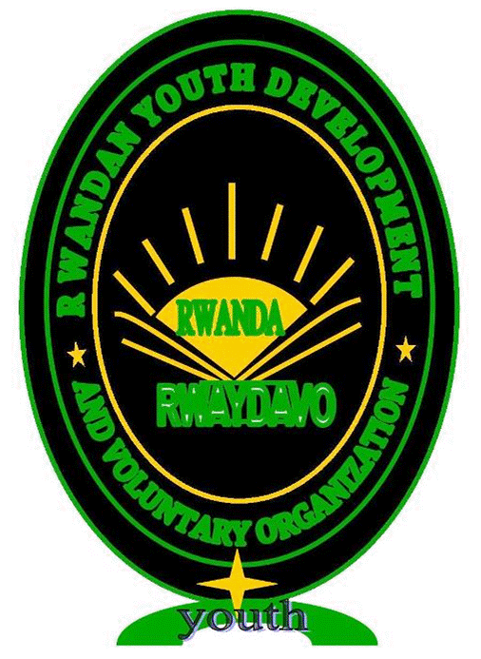RWANDAN YOUTH DEVELOPMENT AND VOLUNTARY ORGANIZATION
(RWAYDAVO)

GLOBAL HANDWASHING DAY NARRATIVE REPORT 2013

The event was carried out on: Tuesday, 15th October 2013, From 01:00 till 04:30
CONTACT PERSON:
Coordinator of Global Handwashing day Rwanda
Ms JEAN DAMASCENE UWIZEYIMANA
RWAYDAVO president
E-mail: rwaydavoprsident@gmail.com
damasdr@yahoo.com

Tel :( +250 ) 0783810006/0722810006

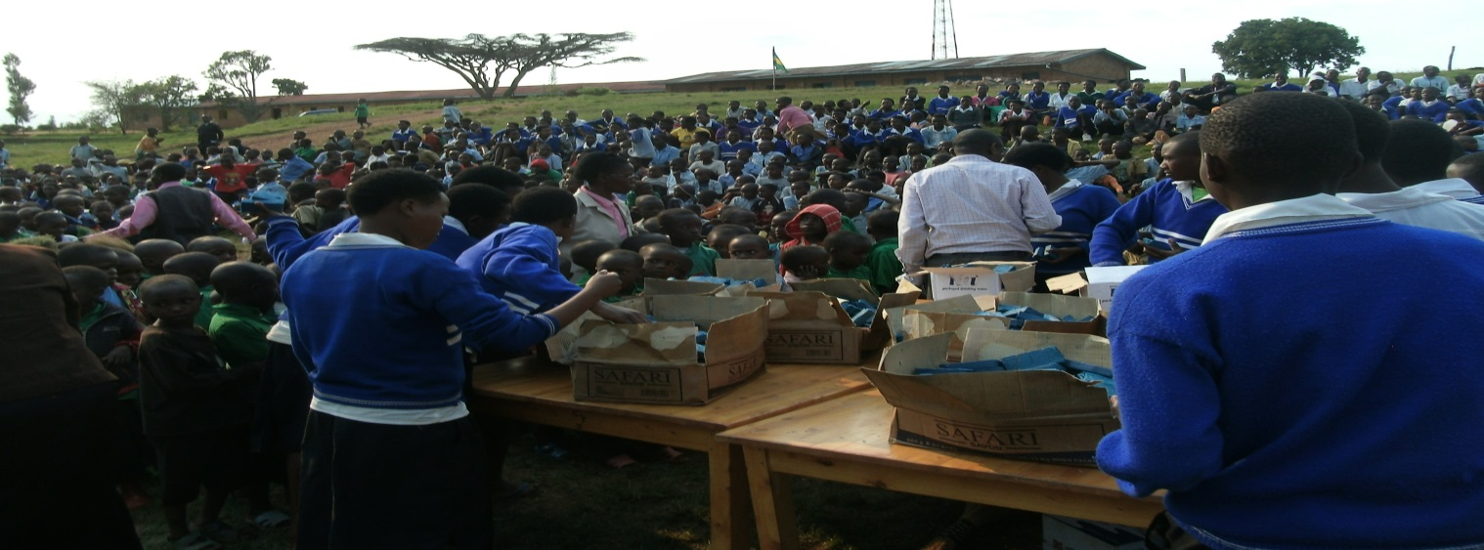
Global Handwashing Day (GHD) is a campaign to motivate and mobilize millions around the world to wash their hands with soap. It takes place on October 15 of each year. The campaign is dedicated to raising awareness of Handwashing with soap as a key approach to disease prevention. Handwashing Day took place for the first time on October 15, 2008, the date appointed by UN General Assembly in accordance with year 2008 as the International Year of Sanitation.
The World Health Organization (WHO) estimates that diarrheal infections claim the lives of 1.87 million children under five each year, making diarrhea the second-most common cause of death among children under five.
UNICEF estimates that diarrhea kills one child every 30 seconds. Scientific research shows that handwashing with soap prevents disease in a more straightforward and cost-effective way than any single vaccine.

GLOBAL HANDWASHING DAY NARRATIVE REPORT 2013

EVENT DESCRIPTION

RWANDAN YOUTH DEVELOPMENT AND VOLUNTARY ORGANIZATION
is local non-governmental, non profit making, community based organization whose main operation is in health empowerment aiming at improving the health and the living standards in underprivileged communities at village and urban level as well as volunteers capacity building.
The organization is working in six programs: Hygiene water and sanitation program, Income generation program. Drug policy and harm reduction program , Sexual and reproductive health program , Peace building and conflict resolution program , HIV/AIDS and Social welfare program,
Organization target group is the vulnerable people who are underrepresented, under estimated and underserved in community development.

Vision

Self-reliant communities and skilled citizen.

ii. Missions and goals of organization

- To improve the living standards in underprivileged communities in Rwanda and to develop the capabilities of volunteers in development work, through sustainable development projects that are community owned, intersectorial and coordinated by RWAYDAVO volunteers
- To promote science and research culture within members
- To initiate programs whose aim is to promote the live standards of the population
- To combat solitude and ignorance by creating cooperation with other association in Rwanda.
Objectives of the organization

- Improving the general sanitation situation in underprivileged Rwandan community

- drug policy and harm reduction

- Peace building and conflict resolution

- Reduction of the prevalence of malaria in the target communities in Rwanda.

- Reduce the prevalence of HIV/AIDS and other STDs.

Global Handwashing Day (GHD) is a campaign to motivate and mobilize millions around the world to wash their hands with soap. It takes place on October 15 of each year. The campaign is dedicated to raising awareness of Handwashing with soap as a key approach to disease prevention. Handwashing Day took place for the first time on October 15, 2008, the date appointed by UN General Assembly in accordance with year 2008 as the International Year of Sanitation. In this year of 2012, it was the sixth time tat
In this year of 2013, it was the first time that Rwandan Youth Development and voluntary organization conducted The international Global Handwarshing on 15th october 2013 . 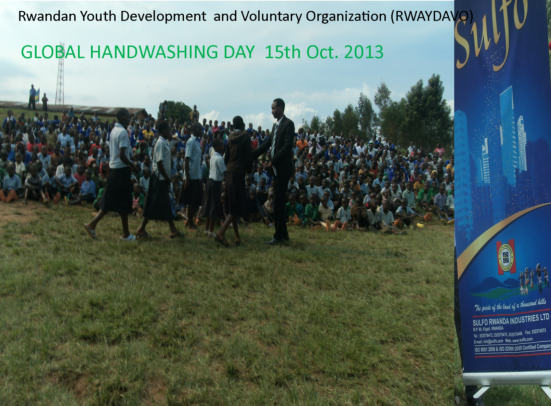
The participants was around 1100 children

OBJECTIVES OF GLOBAL HAND WASHING DAY 2013 .

To reduce poor hygiene related diseases such as diarrhea ,cholera and acute respiratory infections .
To promote School Sanitation and Hygiene Education.
To promote a global and local vision of Handwashing with soap.
SCHEDULE AND ACTIVITIES OF THE EVENT
The event was started around 1:00pm by presenting the visitors; the RWAYDAVO president started the event officially showing children the appropriate manner of washing hands
The event from the beginning to the end was characterized by full security and freedom of participants.

The messages of the day was given in different categories
  - Poems, 2.songs, 3.drama, 4.teachings, 5.speeches
The total participants were around 1100 (girls and boys)

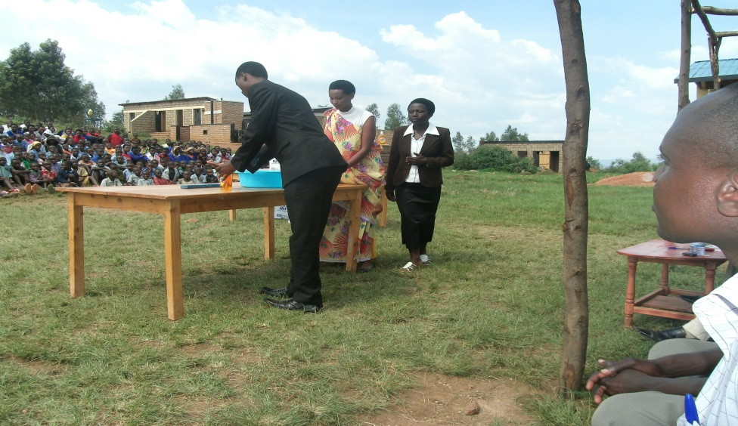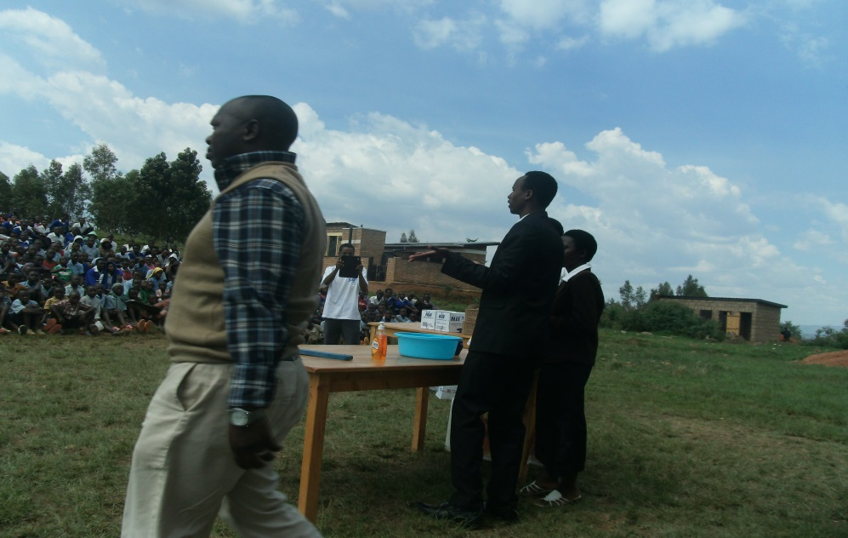

Photos presenting activities of the day from 1:00 to 4:30 pm

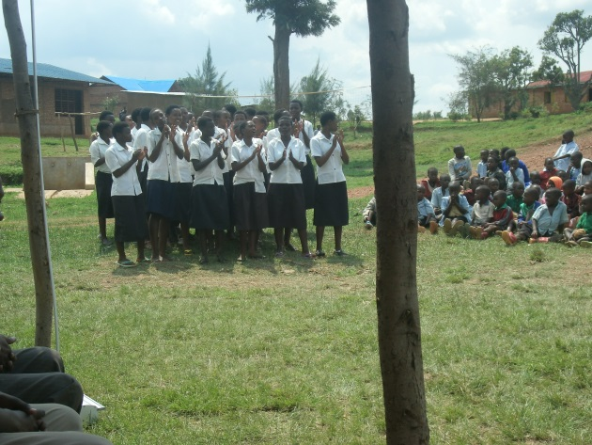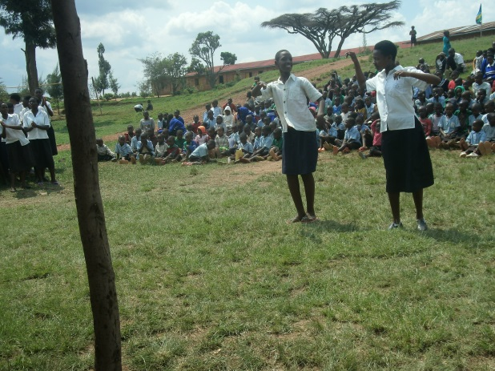
Song presentation
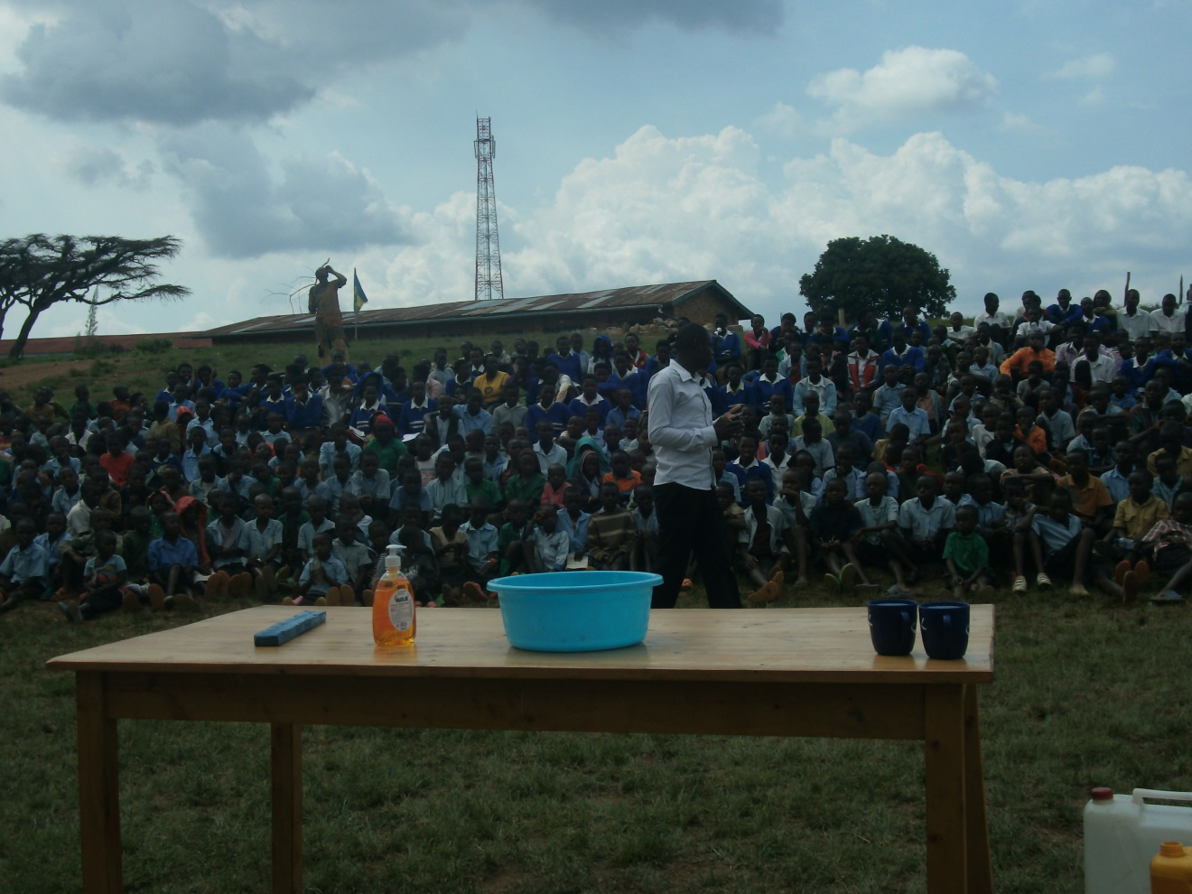
Volunteer of RWAYDAVO conducting teachings

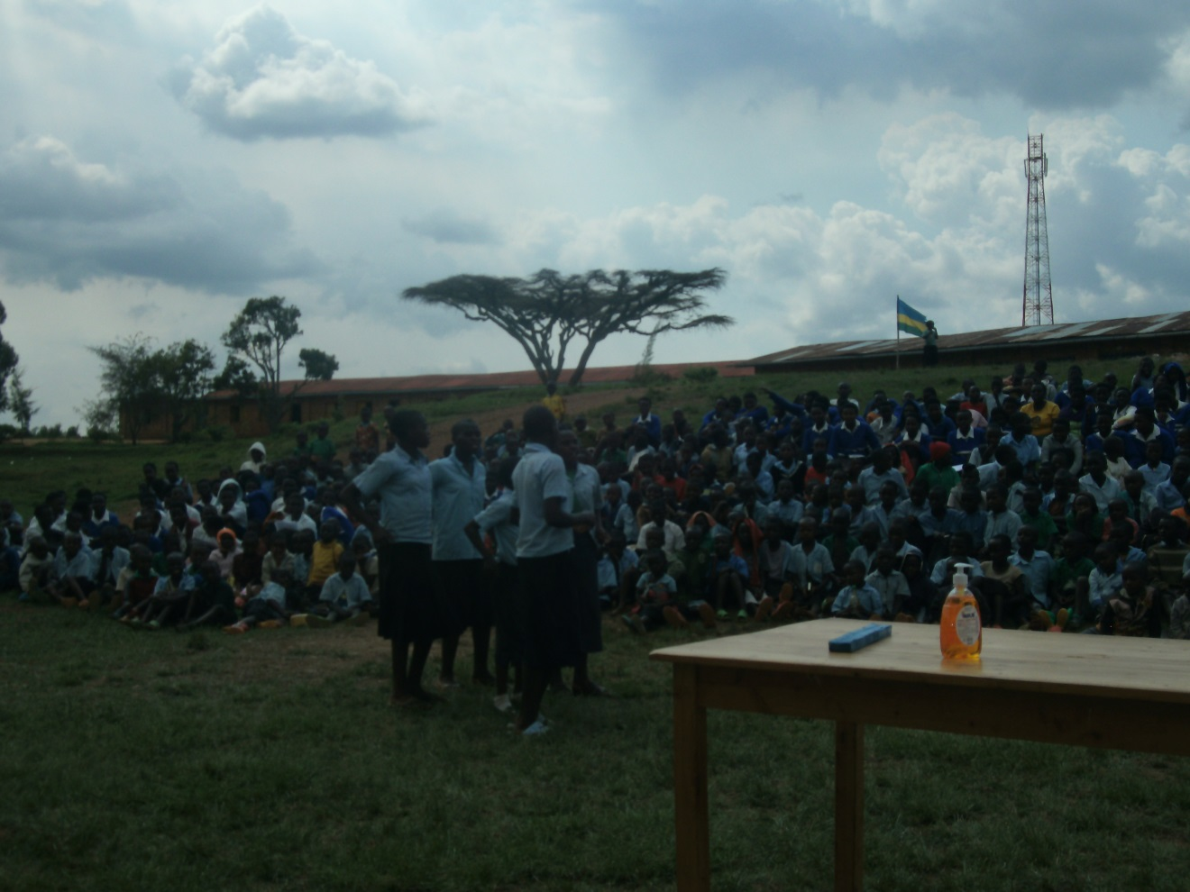
Drama

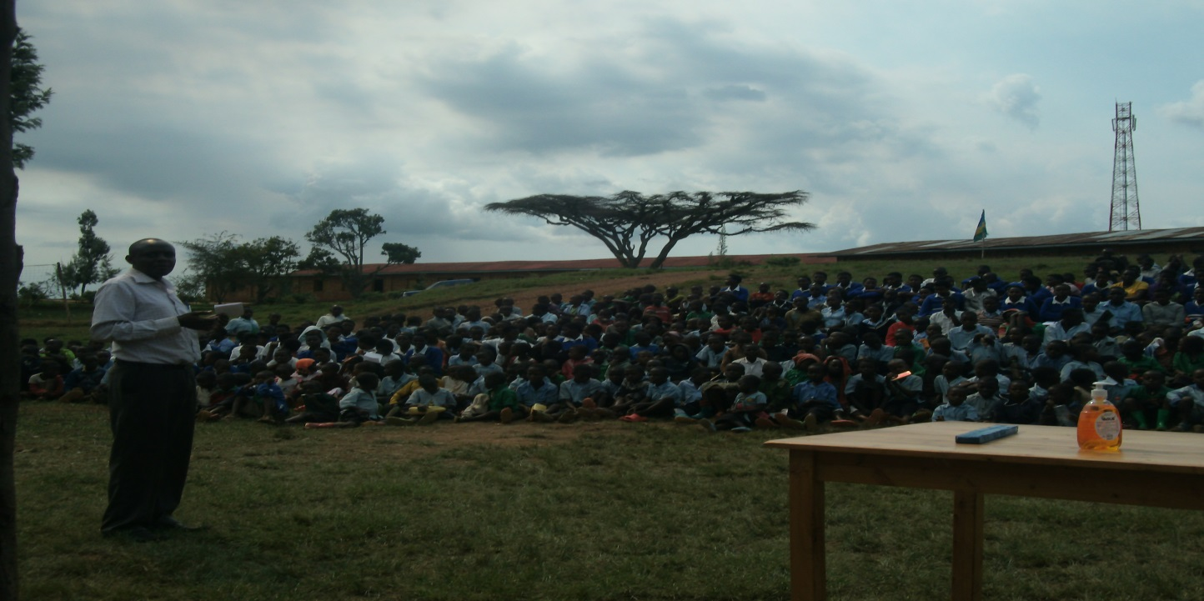
Director of groupe scolaire Burega (speech)
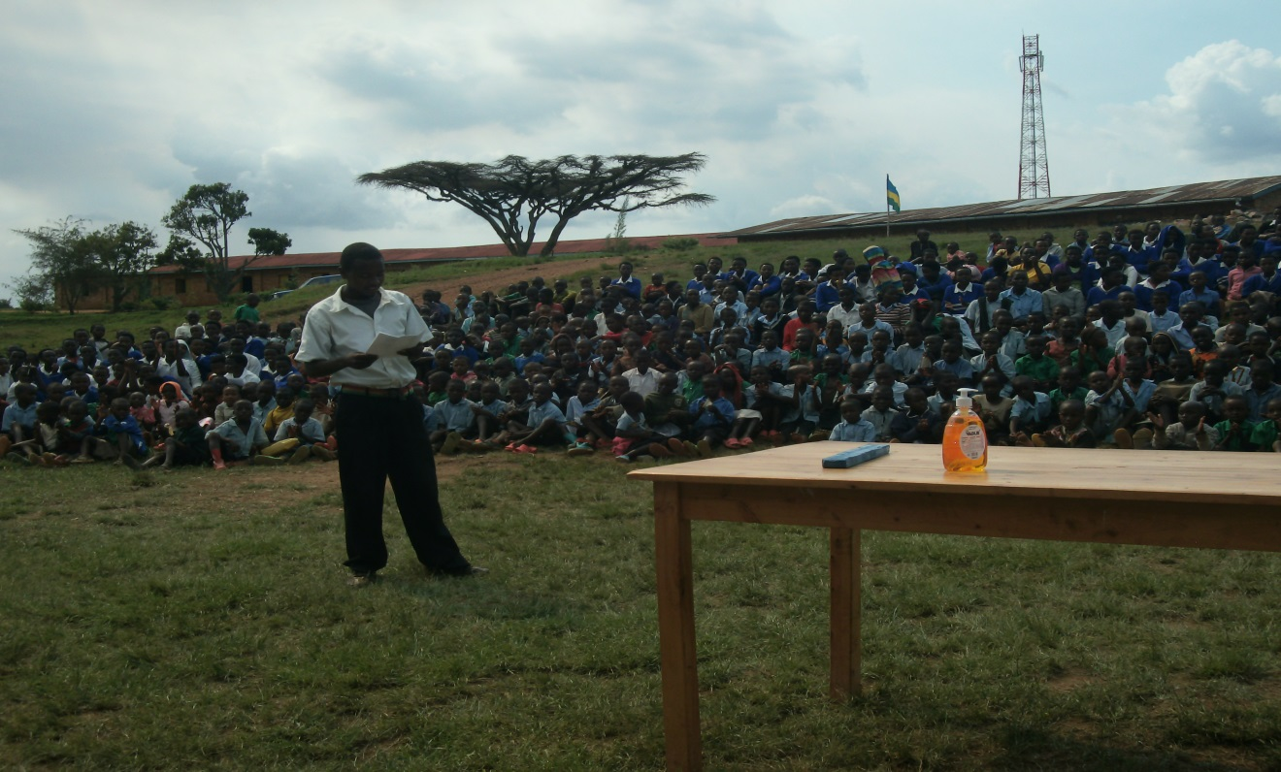
Poem presentation
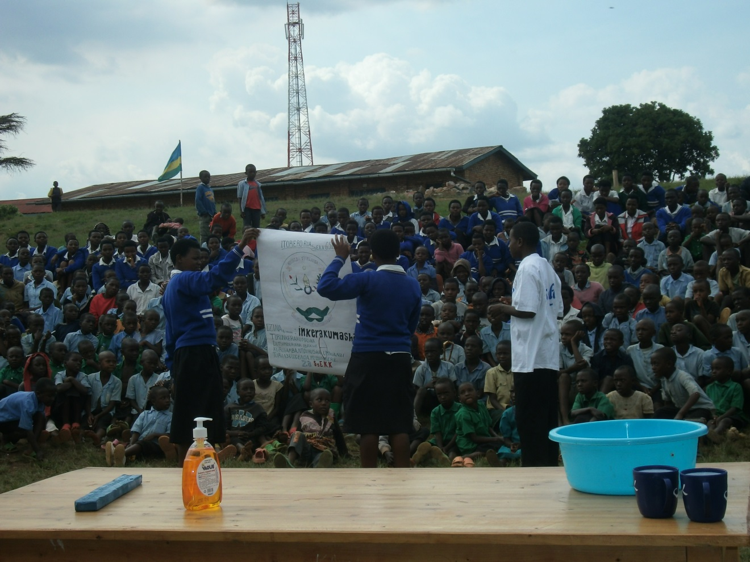
Draw story presentation

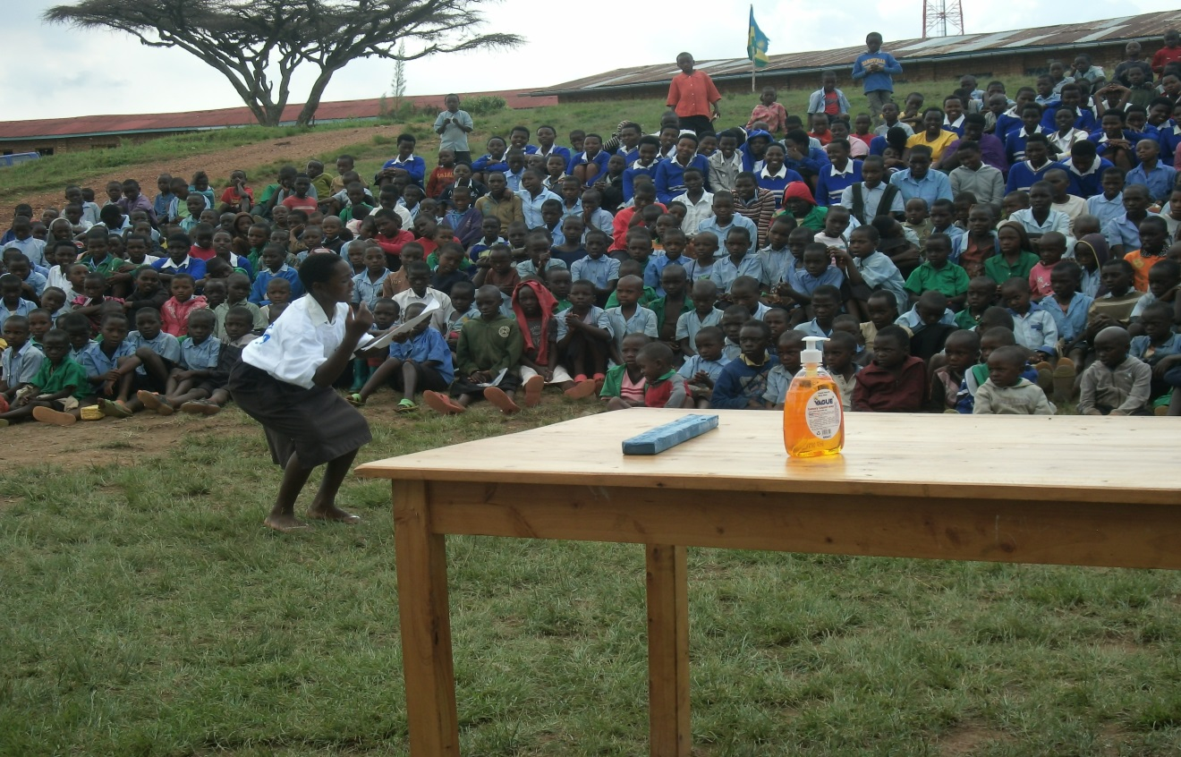
Poem presentation
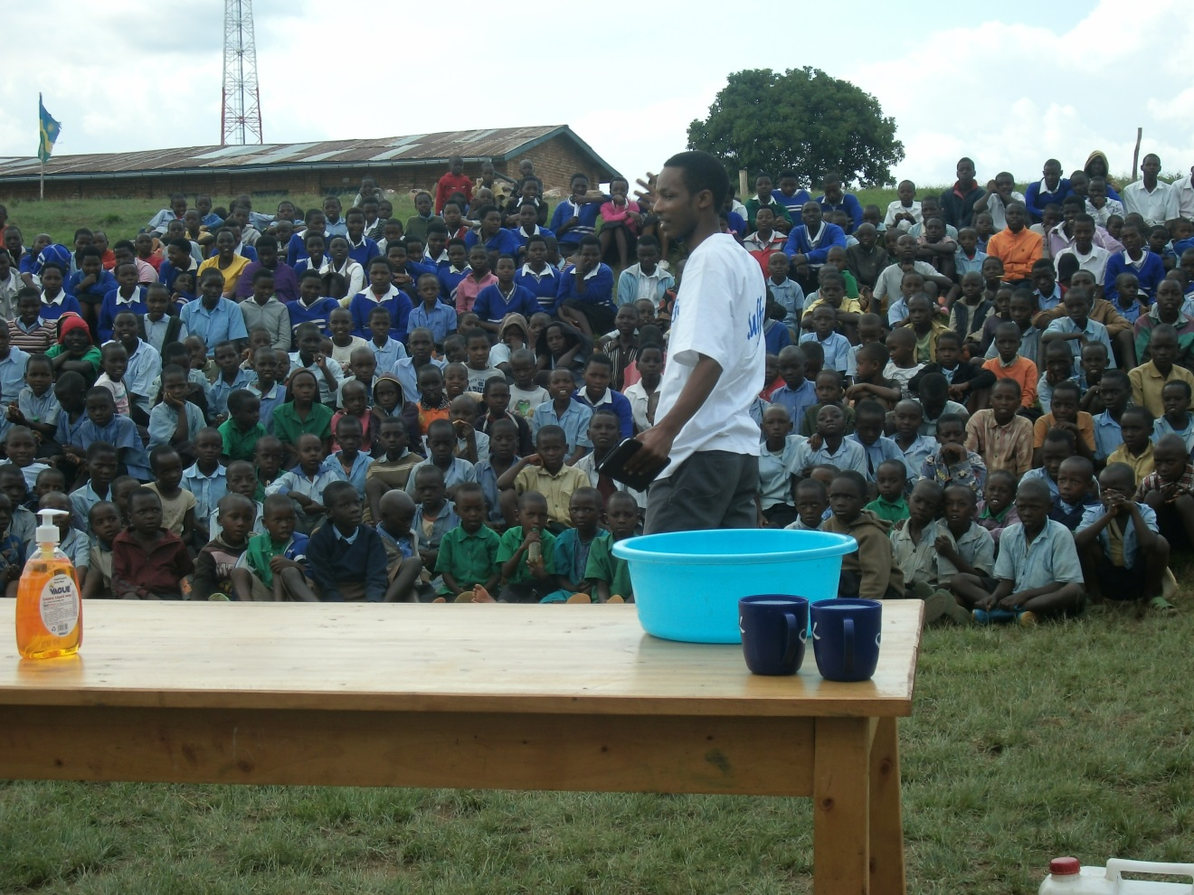
Speech of Sulfo Rwanda industry representative

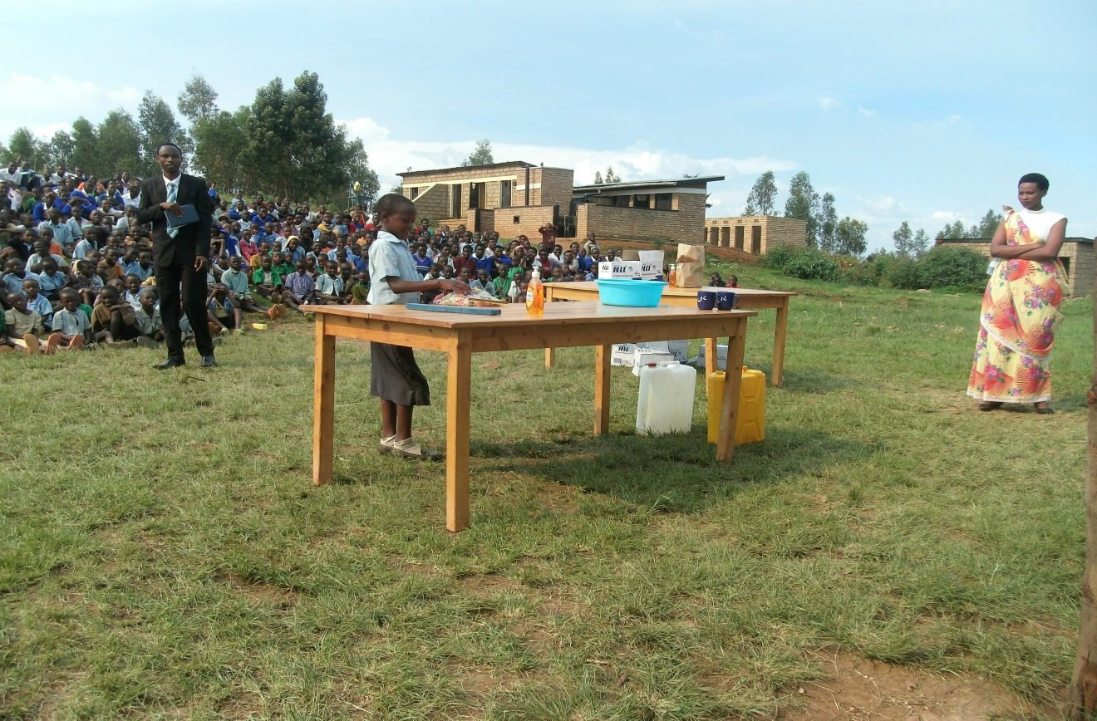
RWAYDAVO president speech

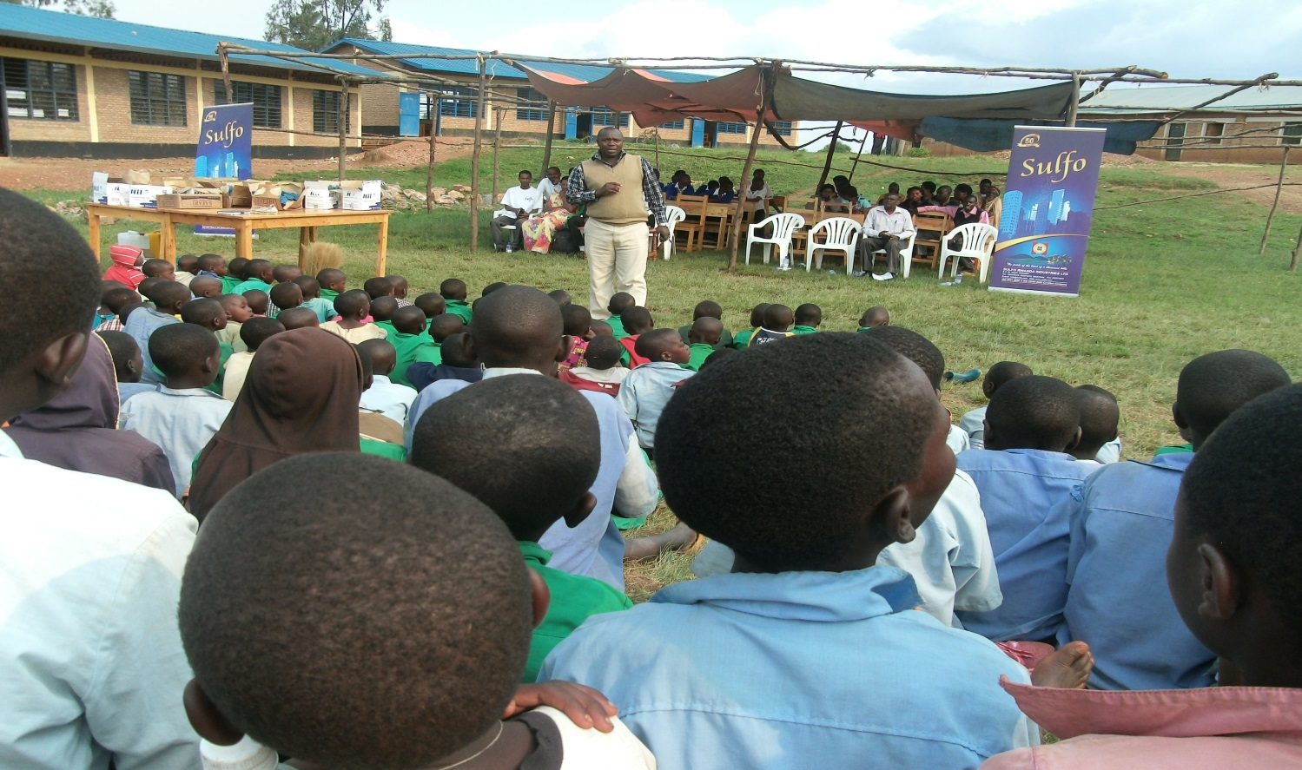
Executive secretory of Burega Sector speech

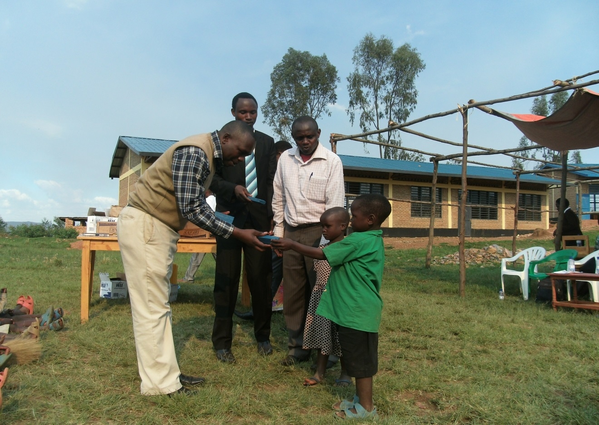
Starting distributing Soaps
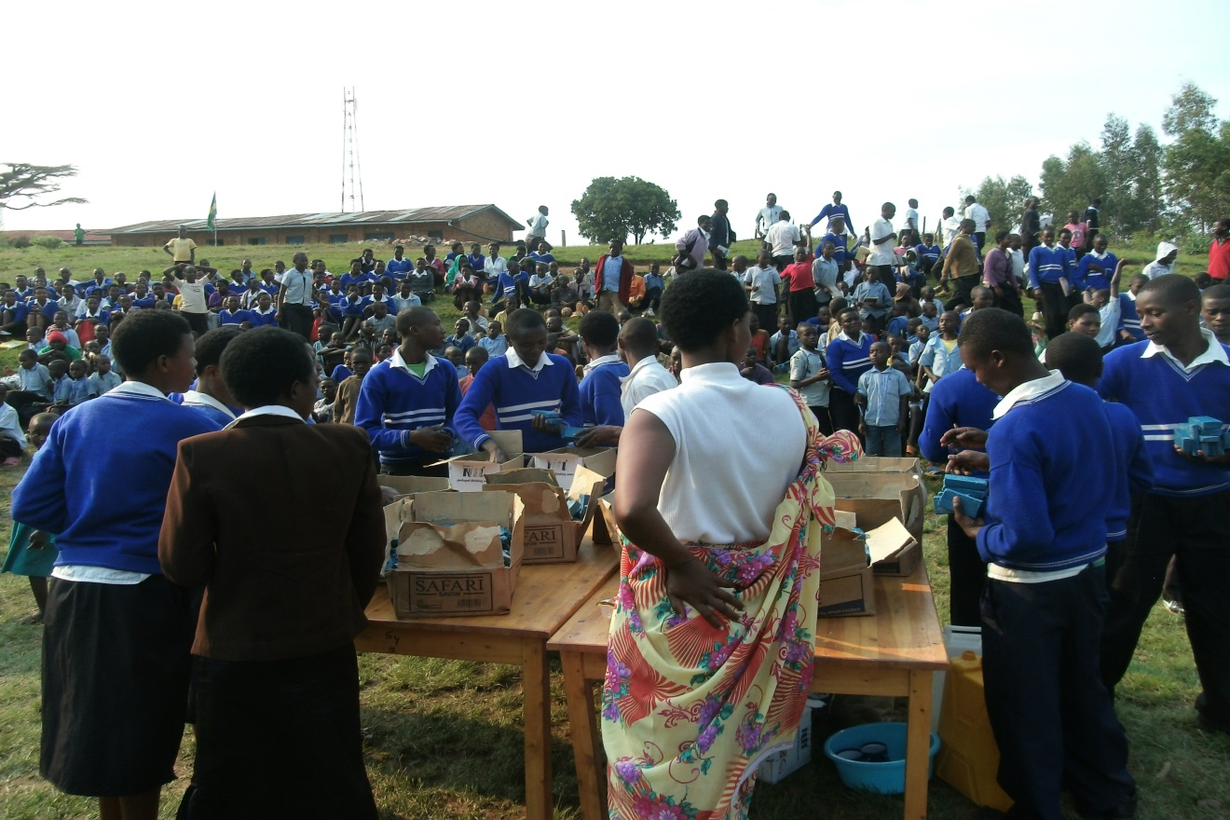
RWAYDAVO volunteers distributing soaps
One thousand soaps was distributed during this event .

- ACKNOWLEDGEMENT

- We thank a lot Rulindo district for official recognition of our organization and We thank a lot Burega sector for the assistance provided for the event implementation
- We thank a lot SULFO-Rwanda for the support provided for Rwandan Youth Development and voluntary organization(RWAYDAVO)
- We thank a lot the National Traffic Police for the security
- We thank a lot Groupe Scolaire Burega
- We thank a lot youth club SHISHOZA 2020 vision for the assistance
- We thank a lot local leaders for their participation
- We thank lot teachers of schools for their commitment to bring children to attend the event.

